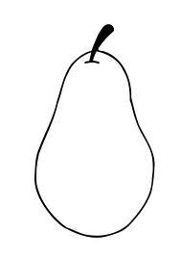

**I. Point**

A TOPIC SENTENCE should STATE THE POINT or PURPOSE OF YOUR PARAGRAPH. It should be Assertive, Specific and Concise.

**II. Evidence**

Examples may include data, evidence or anecdotes which ILLUSTRATE that the point you make in your topic sentence is true. Examples might be one to three or four sentences.

**III. Analysis**

Explanations, Connections, Ramifications. Include a sentence or two connecting your examples to your topic sentence—HOW do the examples illustrate the point? Why does it matter?

**(IV. Re-state!)**

A concluding sentence may have many roles; most importantly, it should REITERATE THE POINT OF YOUR TOPIC SENTENCE. It might also

*· Connect the idea of this paragraph to the thesis statement/overall essay or position*

*· Transition to and introduce the next paragraph*

Point

______________________________________________________________________________________________________________________________________________________________________________________________________

Evidence (3 things reasons)

______________________________________________________________________________________________________________________________________________________________________________________________________

Analysis (why does it matter?)

______________________________________________________________________________________________________________________________________________________________________________________________________

Re-state

______________________________________________________________________________________________________________________________________________________________________________________________________